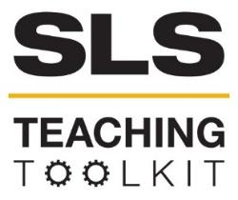 | SLS Case Study: The 11th Street Bridge Park and Community Engagement in Green Infrastructure Planning
Discipline: All | Type: Reading; Discussion | Time Commitment: 30 minutes | Category: Case Studies on Sustainable Communities
Big Ideas: Sustainable Urban Development, Infrastructure: Physical, Technological, Social,;Participatory Processes and Collaborative Governance, Voice & Agency; Systems Thinking; Inequality, Poverty and Sustainable Development
OVERVIEW:
In this case study, read about the 11th Street Bridge Park and its planning process, and learn about how community engagement in green infrastructure planning can help address equitable development concerns such as such as housing affordability, workforce development, small business development, and community culture. The 11th Street Bridge Park is a planned elevated green infrastructure amenity that is being developed on the piers of the old 11th Street Bridge in Washington, D.C.. The project is a unique example of green infrastructure in that its planning process has evolved to focus on how the park can support more equitable development in surrounding neighborhoods. Community engagement and leadership are important components shaping the park’s environmental, economic, and social outcomes. Serve-Learn-Sustain interprets sustainable communities as integrated systems, wherein nature, technology and society all inform each other. As you read this case study, consider these terms as discrete factors, but also as connected.
This tool was contributed by Jessica Fisch.
INSTRUCTIONS:
- Use this case study in the way that works best for your class: assign it as a take-home reading, or as an in-class reading. Supplement the case study with sources from the Additional Readings section.
- Either as a take-home assignment or in-class discussion, answer the Discussion Questions, or craft your own. One option for this would be to divide students into small groups to discuss some or all of the discussion questions, and then come back together as a larger group to discuss the smaller groups’ findings.
SLS STUDENT LEARNING OUTCOMES & ASSESSMENT:
The Serve-Learn-Sustain toolkit teaching tools are designed to help students achieve not only SLS student learning outcomes (SLOs), but the unique learning outcomes for your own courses. Reflection, concept maps, rubrics, and other assessment methods are shown to improve student learning. For resources on how to assess your students’ work, please review our Assessment Tools.
This tool achieves SLOs 1 and 3. See the end of this tool for further details.

Want Help?
Jennifer Hirsch is the contact for this tool. You can reach her at jennifer.hirsch@gatech.edu

11th Street Bridge Park Case Study

Introduction
“Green infrastructure” refers to an interconnected, multifunctional network of greenspace and natural areas that shapes and is shaped by communities’ environmental, economic, and social qualities. The concept may refer to a wide array of natural features, engineered structures, or managed interconnected networks of green space and their associated ecosystem services, including parks, stormwater management features, greenways and trails, green streets, and watershed restoration projects, among other types of projects and greenspaces.
Green infrastructure has a variety of environmental, economic, and social impacts. Planners, policymakers, and elected officials increasingly frame investments in green infrastructure, parks and other green development as opportunities for spurring economic growth, increasing environmental quality, and providing social and recreational amenities in urban areas. Indeed, green urban projects may provide a host of environmental, economic, and social benefits to their cities and neighborhoods, from stormwater management and climate change adaptation, to improvements in public health, to local economic development opportunities (see Figure 1).
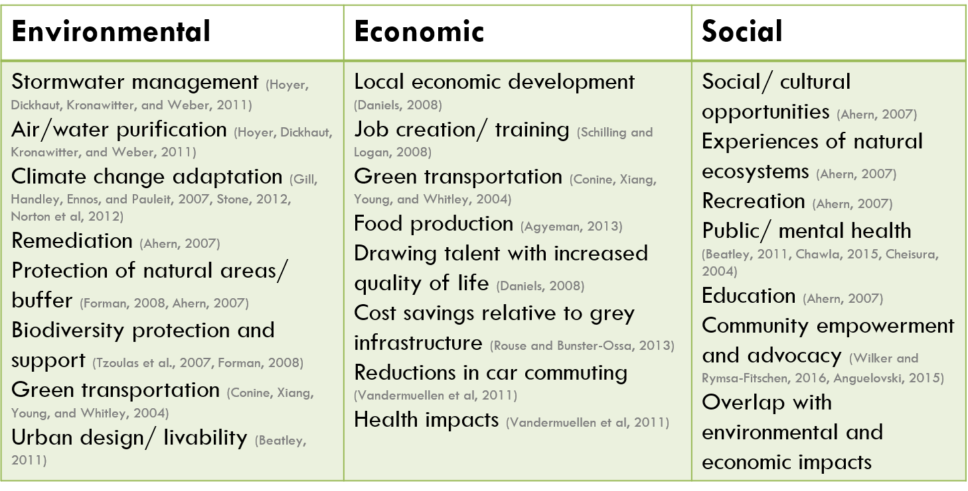
Figure 1: Green infrastructure has a wide variety of environmental, economic, and social outcomes.
While public investment in green infrastructure has the potential to provide a wide range of benefits in urban areas experiencing disinvestment and high rates of poverty, residents of these areas often voice concerns regarding equity issues of gentrification, displacement, or reduced affordability in their neighborhoods. Concerns often center around maintaining housing affordability and preventing displacement in low-income communities and communities of color. Indeed, green infrastructure projects with a variety of functions have been associated with increases in land and housing values, including those focused on addressing environmental justice threats, such as brownfield remediation, as well as projects focused on providing environmental amenities.
Increases in housing values and costs surrounding new projects often lead to gentrification and displacement, with wealthier residents moving into the area while lower-income communities are forced out or unable to move in, due to rising housing costs. Displacement may include:
- Direct displacement of residents due to increases in housing costs;
- Indirect displacement, in which low-income residents cannot afford to move into the area;
- Cultural displacement, or the loss of community culture and institutions due to population shifts within a neighborhood, and
- Political displacement, in which residents may not feel that they have the ability to participate in and shape neighborhood change.
Gentrification and displacement often occur along racial lines, with wealthier, white residents attracted to new amenities moving into neighborhoods, while lower-income communities of color are more likely to experience displacement.
While gentrification and displacement of neighborhood residents presents an important threat surrounding green infrastructure, planning processes that engage deeply with communities surrounding a new green infrastructure project may present an opportunity to support more equitable development. In particular, projects with strong community engagement and leadership components are more likely to incorporate residents’ concerns into green infrastructure projects and planning processes, thus shaping projects in ways that support community wellbeing and quality of life.
This green infrastructure conceptual model (see Figure 2) demonstrates how green infrastructure interacts with environment and health, housing and economic development, and social and community factors to shape community empowerment, quality of life, and wellness. Notably, community engagement and the social capital that can be developed through green infrastructure planning processes are often supportive of more equitable project outcomes. For example, a project with a strong community engagement and leadership component may be more likely to address community priorities such as workforce development or housing affordability. Contextual factors, such as existing policies and race and income of residents in surrounding neighborhoods, can also shape how green infrastructure impacts communities. For example, a city with strong affordable housing policies in place would be in a better position to address concerns of rising housing costs surrounding green infrastructure projects than one without those policies in place.
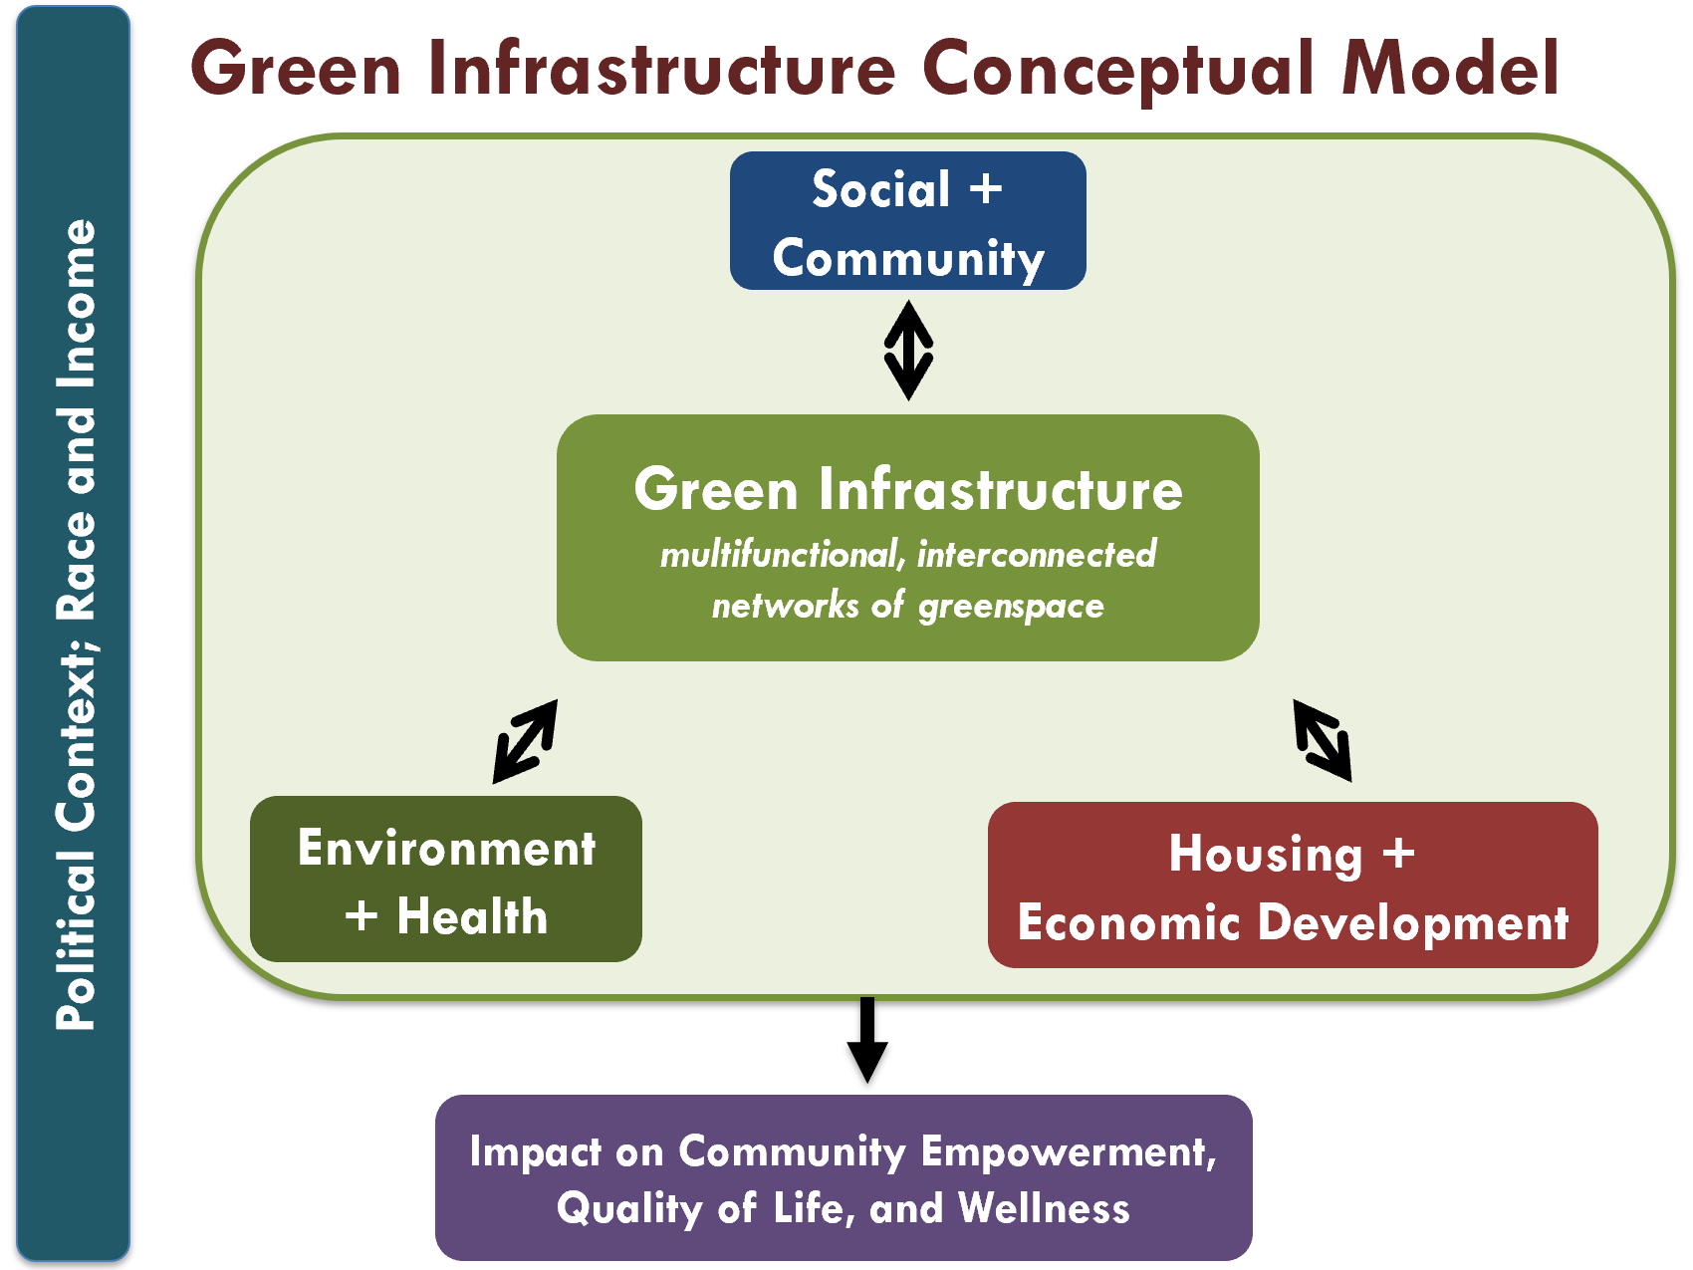
Figure 2: Green infrastructure shapes and is shaped by environment and health, housing and economic development, and social and community factors, interactions which impact community empowerment, quality of life, and wellness. Green infrastructure’s impacts are shaped by the political context in which it is implemented, and the race and income of surrounding communities.

The 11th Street Bridge Park

Project Overview
In examining the role of community engagement and leadership in shaping green infrastructure projects and their impacts, the 11th Street Bridge Park provides a useful case study. The park is an elevated, multifunctional green infrastructure project to be developed on the piers of the old 11th Street Bridge in Washington, D.C.. Slated to open in 2023, the project is based in the nonprofit Building Bridges Across the River, a community organization working in the nearby Congress Heights neighborhood since 1997. The park is planned to include amenities such as outdoor performance spaces, playgrounds, urban agriculture, an environmental education center, public art, and kayak and canoe launches. Its goals include improving health disparities and supporting healthy communities through providing opportunities for recreation, connecting the surrounding Ward 8 neighborhoods to the Anacostia River and to the Capitol Hill/ Navy Yard area, and serving as an anchor for inclusive economic activity.
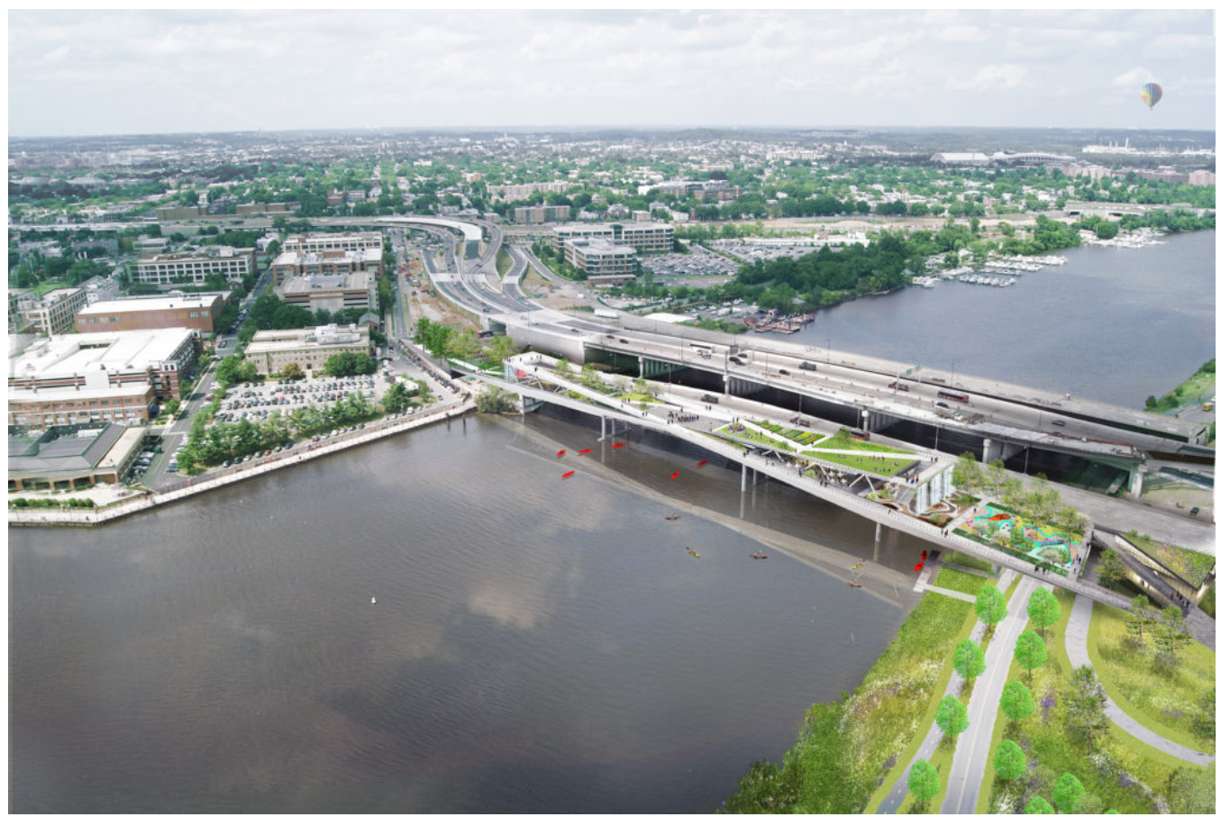
Figure 3: Rendering of 11th Street Bridge Park from above. The park will connect lower-income Ward 8 communities (right) with upper-income Washington, D.C. neighborhoods (Building Bridges Across the River, n.d.)
Figure 4: Plans for the 11th Street Bridge Park include features such as rain gardens, an amphitheater, a plaza, an outdoor classroom, and teaching gardens (Building Bridges Across the River, n.d.)

Context of the Park’s Development
The 11th Street Bridge Park will span the Anacostia River, connecting upper-income, rapidly-growing areas of Washington, D.C., to lower-income, predominantly African-American neighborhoods in the Ward 8 neighborhoods east of the Anacostia River. Washington, D.C. is highly segregated by race and income, with the city’s Ward 8 ‘east of the river’ neighborhoods having much higher proportions of low-income and African-American residents than the rest of the District. The Ward 8 neighborhoods are also geographically segregated, with the river serving as a barrier between the Ward 8 neighborhoods and the rest of the District.
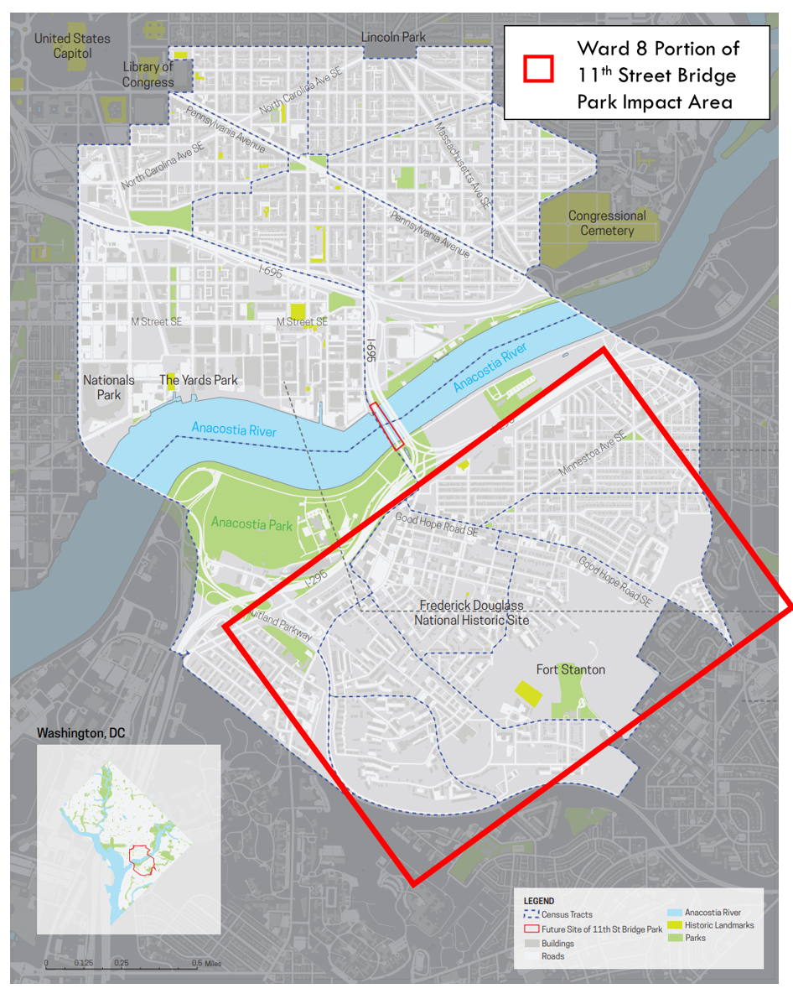
Figure 5: Location of the 11th Street Bridge Park in Washington, D.C. (highlighted in red) (Building Bridges Across the River, n.d.)
Racial segregation in Washington, D.C. has a long history that continues to shape residential patterns. Beginning in the 1950s with the integration of the District’s schools, the Ward 8 neighborhoods suffered the impact of white flight, urban renewal, and the concentration of public housing in the area, the effects of which continue to the present. The east of the river neighborhoods have also experienced significant disinvestment relative to the rest of Washington, D.C., including a lack of both public and private investment in necessities such as infrastructure and services.
Since 2000, Washington, D.C. has experienced an influx of more affluent, predominantly white residents, and the proportion of African American residents in the District has declined. As the city’s population has continued to grow, housing costs have risen considerably, and the potential for displacement of lower- and middle-income residents due to high housing costs has become a top concern for District residents.
Movement of populations back to city centers is a national trend that is not specific to Washington, D.C. As cities compete to attract residents and jobs, investments in green infrastructure are one way that governments, nonprofits, and community groups have invested in urban centers to increase quality of life, support economic development, and address environmental issues such as stormwater management. Indeed, as described in the introduction to this case study, green infrastructure can provide many environmental, economic, and social benefits to cities and their residents.
Yet, within the historical and present-day contexts of segregation, inequality, and the impacts of urban renewal common to many cities, residents of neighborhoods in which green infrastructure projects are proposed often express concerns associated with whether the new amenities will trigger increases in housing costs in surrounding neighborhoods, and whether existing residents will benefit from investments in green infrastructure. The same concerns have arisen regarding how the 11th Street Bridge Park will impact the lower-income communities of color in the Ward 8 neighborhoods surrounding the project. How will the project impact housing values and costs? Will current residents be able to afford to stay in their homes? Will new residents be able to access affordable homes to move into? How might the project benefit residents with aspects such as access to jobs or workforce training relating to the park’s construction? The following sections discuss the park’s relationship with outcomes relating to environment and health, housing and economic development, and community/ social capital, including how residents and community groups have shaped the project to support more equitable outcomes.

Environment + Health
Planning for the 11th Street Bridge Park initially focused on whether residents in surrounding neighborhoods wanted the park, and, if they did, how the park would be designed and which amenities would be included. Many of the design elements proposed by residents centered on shaping the environmental qualities of the park and providing opportunities for improving community health. Specific ideas for the park that came out of these initial meetings included environmental amenities such as gardens and environmental education center, as well as recreation and health-focused amenities such as access to the river through canoe and kayak launching spaces and play spaces. In this way, once developed, the multi-functional park will shape the environment and health qualities of the surrounding neighborhoods.
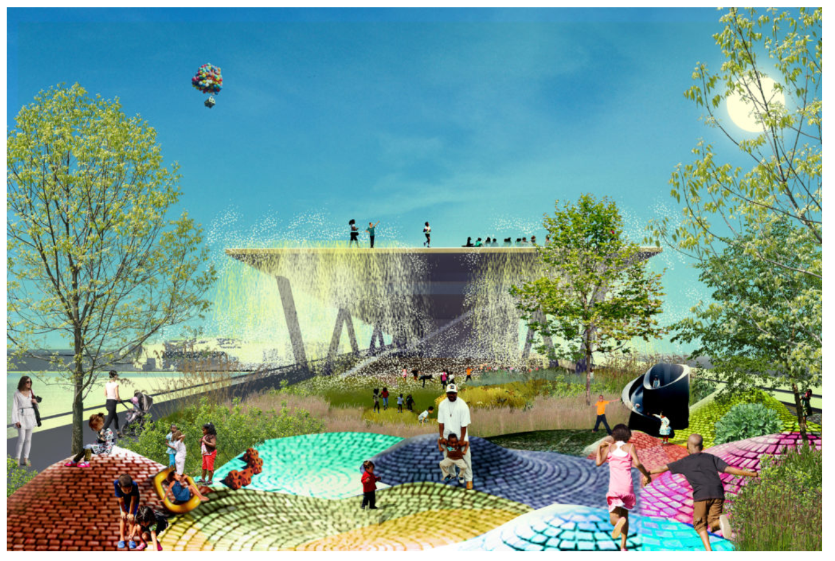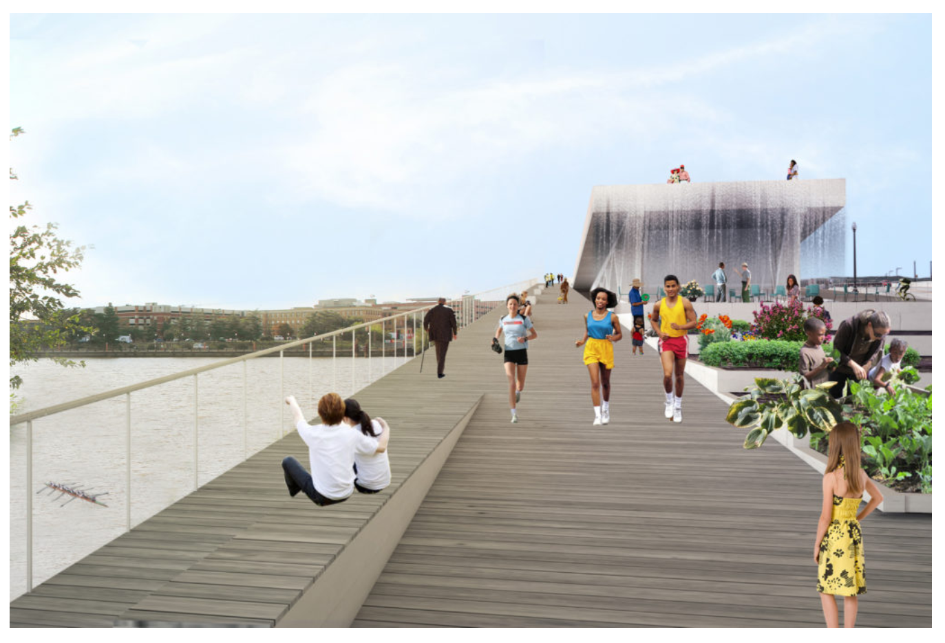
Figure 6: Renderings of the park’s playspace and a view from its garden. By providing amenities from recreational spaces to rain gardens, the park will shape the environment and health outcomes in surrounding neighborhoods (Building Bridges Across the River, n.d.).

Housing + Economic Development
Planning for the park has brought to the forefront questions of how green infrastructure might impact housing and economic development. How might the park be designed to provide benefits to residents in surrounding neighborhoods while also addressing threats of gentrification and displacement? Initial studies also concluded that the park would impact real estate values in the surrounding neighborhoods, and housing prices have indeed increased in surrounding neighborhoods since early announcements of plans for the park in 2014. Further, a large proportion of both renters and homeowners in the east of the river neighborhoods in the park’s impact area are already cost-burdened (i.e., spending more than 30% of income on housing costs), so displacement of current residents due to increasing housing costs presents an important threat (see Figure 7). These factors all point to the potential for the 11th Street Bridge Park to shape housing and economic development in surrounding neighborhoods.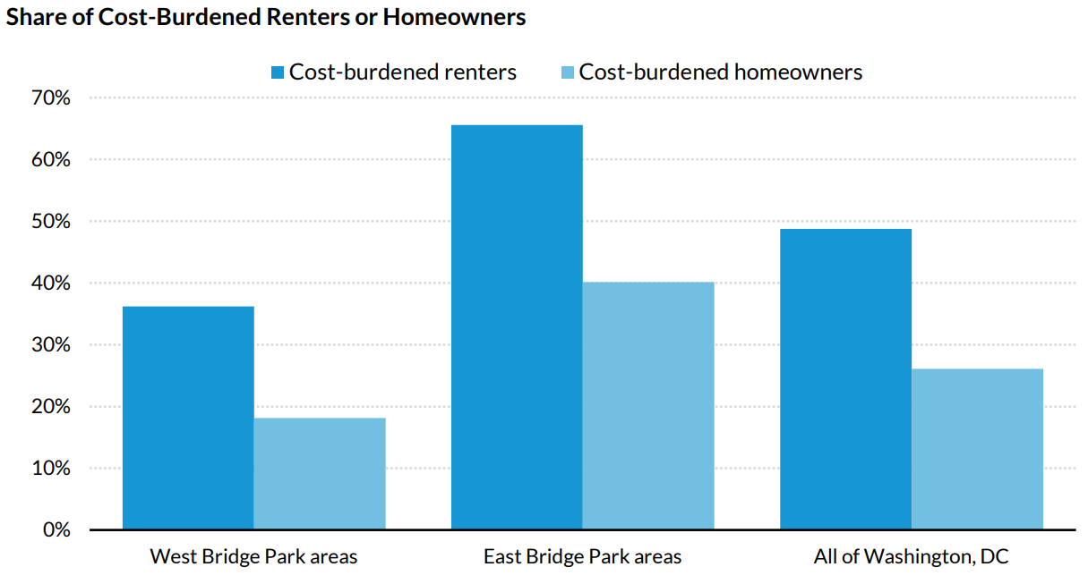
Figure 7: Proportion of renters and homeowners who are cost-burdened in the east and west of the river neighborhoods surrounding the Bridge Park and in all of Washington, D.C., based on American Community Survey 2011-2015 data (Urban Institute, 2019). The fact that high proportions of both renters and homeowners in the city’s east of the river neighborhoods are already cost-burdened (spending more than 30% of income on housing costs) makes rising housing costs surrounding the 11th Street Bridge Park an imminent threat.
In response to these concerns, one of the recommendations to support housing affordability that emerged from the planning process was the development of a community land trust (a tool to acquire property in the neighborhoods surrounding the project to be maintained as affordable housing in perpetuity). The park’s Douglass Community Land Trust is now in the early stages of development, and a Land Trust Advisory Committee, comprised primarily of residents of the park’s surrounding neighborhoods, has led the trust’s development. Having residents of the park’s impact area serve as leadership has shaped the land trust’s strategies, including important aspects such as defining what counts as affordable housing. Specifically, residents defined affordability according to incomes in Ward 7 and 8 rather than in the District as a whole, and have targeted the land trust’s efforts to benefit very low-income residents and renters. In this way, having residents in leadership roles has shaped how the park will impact surrounding communities, including both the development of the land trust and how it will operate.

Social + Community
In addition to impacts on environment, health, housing, and economic development, the 11th Street Bridge Park has catalyzed and been shaped by strong community engagement and social capital.

Rooting the Park in the Community
Early on in planning efforts, the park’s leadership prioritized having the project based in the community, intentionally deciding not to create a new nonprofit but rather to embed the park’s management in an existing organization located in the surrounding neighborhoods. They engaged with Building Bridges Across the River, a nonprofit community organization based in the nearby Congress Heights neighborhood since 1997, to manage the project and support fundraising efforts. Building Bridges Across the River has engaged Congress Heights and the surrounding neighborhoods for decades through their facility with services including a medical clinic, arts programs, a school for girls, and a Boys and Girls Club under the same roof. As one 11th Street Bridge Park staff member described,
“Having us become part of a nonprofit that was already deeply embedded in the community was important and sent and continues to send an important message that the nonprofit that’s working with the City on this is based east of the river.”
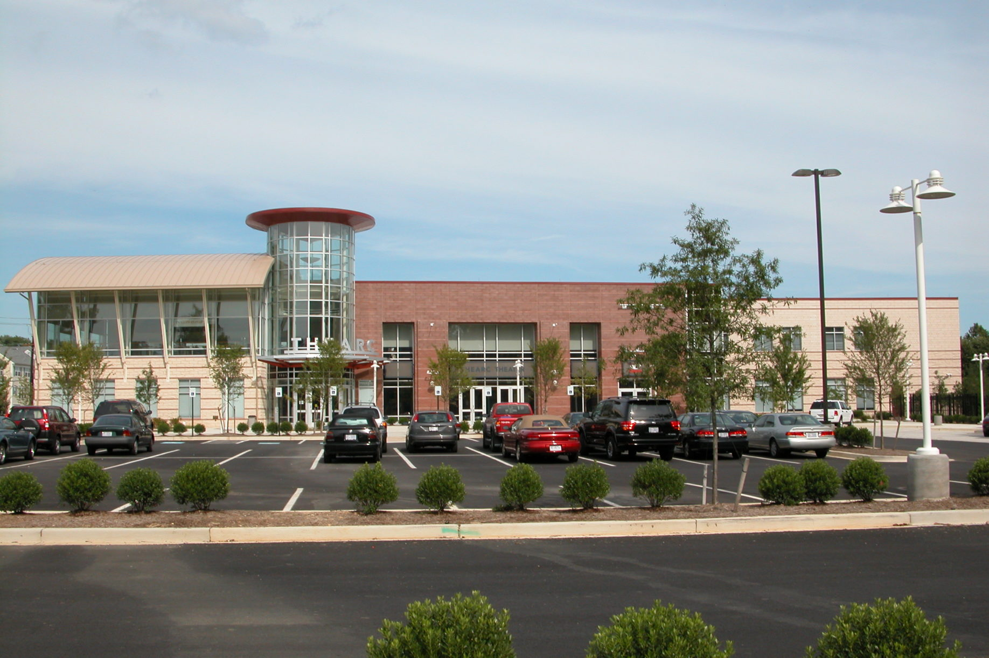
Figure 8: Building Bridges Across the River’s THEARC campus, developed in 2005 and expanded in 2018, includes three buildings, a farm, and a playground. The space supports collaboration among partner organizations and provides residents of surrounding neighborhoods with access to educational, health, cultural, recreation, and social service programs. 11th Street Bridge Park project’s formation within this existing community organization has supported the park in building strong community partnerships.

Prioritizing Community Engagement and Equitable Development
In addition to basing the project in the surrounding neighborhoods, the park’s leadership also prioritized and took action on feedback from neighborhood residents. After hearing concerns from residents regarding housing affordability, displacement, small business development, and the ability of residents to participate in the workforce opportunities created by the park’s development, leaders saw the need to engage in planning efforts to ensure that the project benefits and serves the needs of current residents. As one staff member described,
“When we were out there in those early hundreds of meetings, we were hearing lots of programming ideas, which is important to make sure that the residents, that this future park does meet the needs of those residents, but we also heard other things. We heard that well, who’s going to build this park? How do we ensure that this park can benefit the nearby residents? How do we make sure that this park is for us? And I think this is particularly true in a city that has rapidly gone through change…and the demographics are really changing here in D.C…We knew we needed to do more after the design was selected.”
To address these concerns, the park’s leadership began looking at how similar projects around the country had addressed concerns associated with displacement and community benefits surrounding green infrastructure projects, including the efforts of the Atlanta Beltline, the L.A. River Project, and the Highline in New York City. As one staff member noted,
“We saw that these big parks- signature parks- can be a wonderful amenity, but they also can have unintended consequences, like rising property values. Now if you own a house, that’s great, ‘cause your house is worth more, but what about for the 75 percent of renters who live east of the river?”
To provide a basis for policy and program recommendations, the project’s leadership brought together an Equitable Development Task Force of experts from the Urban Institute; the Local Initiatives Support Corporation (LISC) D.C., a community development financial institution; the D.C. Fiscal Policy Institute, a local think tank; and the D.C. Office of Planning to examine the park’s impact area, which they defined as a 1-mile area surrounding the bridge. Areas of analysis included aspects such as changes in property values over time and demographics in the park’s impact area. Initial analysis confirmed that the park would need to take a proactive approach in order to support more equitable outcomes around concerns such as housing affordability.
Because of this early analysis and feedback from residents, park planners saw the need for an entirely separate planning process that would engage the community around equitable development concerns. The Equitable Development Task Force led the planning process for the park’s Equitable Development Plan, which took place over about eight months from 2014 to 2015. With the goal of forming strategies to support more equitable development, the process brought together neighborhood residents and representatives of more than 50 nonprofit organizations, community groups, government agencies, and think tanks. The final plan included 19 recommendations in the three categories of workforce development, small business development, and housing affordability (the updated version of the plan, released in 2018, adds additional goals for supporting arts and culture). To support the implementation of the strategies in the Equitable Development Plan, the park hired an Equitable Development Manager whose primary focus would be to implement the strategies developed with the community during the equitable development planning process. Several corporate and nonprofit sponsors have also come forward to fund the implementation of the plan’s strategies.
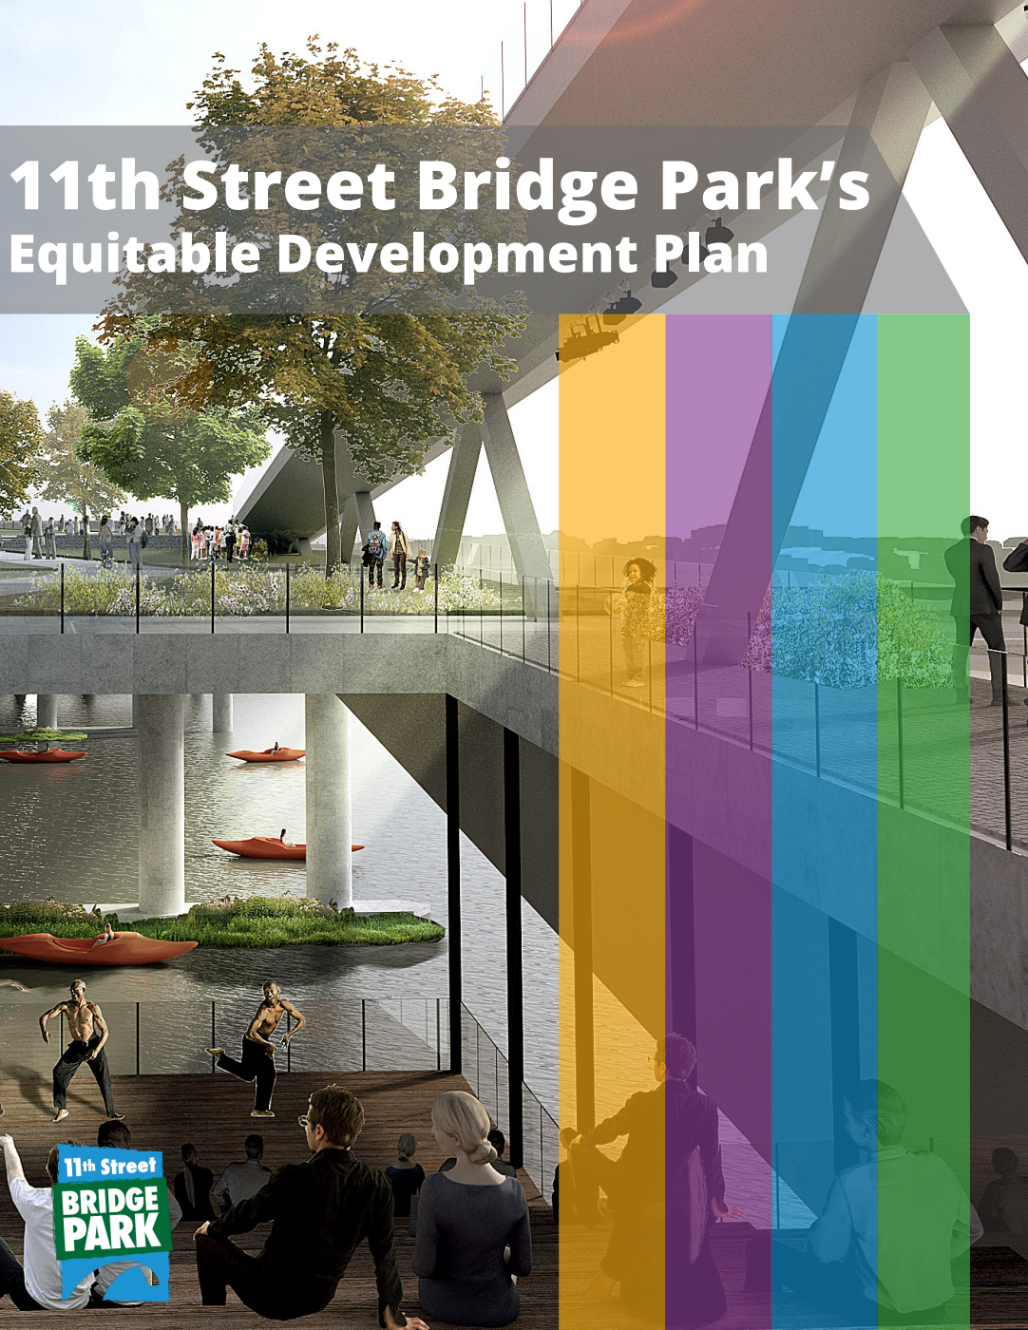
Figure 9: The 11th Street Bridge Park’s Equitable Development Plan contains strategies to support housing affordability, workforce development, small business development, and arts and culture within the surrounding neighborhoods (Building Bridges Across the River, 2018).

Political Context of Washington, D.C.
In examining how an individual project such as the 11th Street Bridge Park supports or hinders equitable development outcomes, it is also important to consider the broader policy environment in which projects are developed. The 11th Street Bridge Park did not develop its equitable development strategies in a vacuum; rather, the park’s engagement with communities around issues of equitable development was supported by broader policies, programs, and funding in place in Washington, D.C. around issues such as affordable housing. The city has a broad set of policies in place in support of affordable housing, including the Housing Production Trust Fund, which provides $100 million annually to support the development of affordable housing, and the Tenant Opportunity to Purchase Act, which provides tenants the first opportunity to purchase the building they live in when a landlord wants to sell the property. The park’s land trust plans to utilize policies and funding mechanisms such as these, as well as other potential city funds, to support its efforts to acquire properties and ensure that they stay affordable into the future. In this way, through available funding and supportive policies, the city’s political context has supported the 11th Street Bridge Park in creating more equitable outcomes around housing affordability.

Toward More Equitable Development
As the park will not be fully developed until 2023, its outcomes with regard to supporting inclusive, equitable development remain uncertain. Several promising initiatives (including the community land trust discussed above) have begun to be put in place, indicating that the project is making strides toward its goal of becoming a driver of inclusive development for the surrounding neighborhoods. In addition to the community land trust, outcomes of the park’s equitable development efforts include a partnership with the Washington Area Community Investment Fund (Wacif) to provide more than $500,000 in loans to small businesses in wards 7 and 8; technical assistance for small businesses; a construction training program in partnership with Skyland Workforce Center; a homebuyers club in which participants purchased more than 70 homes; and workshops to support community leadership and empowerment. While these equitable development outcomes are promising, supporting more equitable development in areas such as housing affordability, job creation, and workforce development also depends on city-level policies as well as continued collaboration among and strengthening of D.C.’s network of government, nonprofit, community, and business partners working toward achieving these goals.
Further, in evaluating results, it is important to differentiate the achievement of equitable development results from the achievement of social equity as a whole. As Bogle, Diby, and Cohen (2019) of the Urban Institute describe,
“achieving a set of equitable development results is not the same as achieving actual equity (i.e., fairness and justice) for an historically marginalized community. After all, it is possible to imagine any number of equitable development projects being completed in a previously disinvested-in neighborhood without true equity ever being achieved. In other words, more affordable housing, small businesses, jobs, and cultural experiences may be preserved or created without there ever being enough of these things to prevent displacement of many current residents, much less to substantially mitigate the widespread effects of systemic racism on black and low-income residents living in places like DC’s Ward 8” (p. 42).
In this way, it is important to consider how individual project outcomes contribute to the broader context of social equity in the neighborhoods surrounding the park.

Conclusion
Overall, the 11th Street Bridge Park presents a useful case study for considering a variety of questions with regard to supporting equitable development through community engagement in green infrastructure planning, including:
- how individual green infrastructure projects create environmental, economic development, and social outcomes,
- how green infrastructure planning efforts that support in-depth community engagement and prioritize addressing equitable development concerns can support more equitable development around concerns such as housing affordability, workforce development, small business development, and community culture,
- the importance of community engagement and leadership in shaping the outcomes of green infrastructure projects, and
- how the broader political context of cities shapes how projects are able to address questions of equitable development.
Use the discussion questions below to think about how the park and its context interact to shape outcomes for the surrounding neighborhoods.

Discussion Questions
- Issues of environment and health, economic development, and community are interconnected.
  - What aspects of the 11th Street Bridge Park case demonstrate this interconnectedness? Cite your answers from the case study itself or the resources under Further Reading below.

- The focus on community engagement and leadership is a unique aspect of the 11th Street Bridge Park planning process.
  - How did community engagement and leadership increase the park’s focus on community priorities and equitable development concerns?
  - What strategies supported residents in shaping the park to meet their needs?
  - How might the park have turned out differently if it focused less on community input and provided fewer opportunities for community leadership?
  - What other community engagement strategies might be put in place to support more equitable development in green infrastructure planning?

- Cities’ political context shapes what individual green infrastructure projects are able to accomplish.
  - How did Washington, D.C.’s political context (e.g., affordable housing policies, programs, or funding, support for addressing affordable housing concerns) shape what the 11th Street Bridge Park was able to accomplish around equitable development?
  - How might D.C.’s supportive political context around affordable housing differ from other cities, and how might that impact the outcomes of green infrastructure projects?

- The need for Environmental Justice manifests in many different ways, in many communities.
  - How can we apply the lessons we have learned about the 11th Street Bridge Park to green infrastructure planning in Atlanta?
  - How can you use the skills you're developing in your major studies to support more equitable development in sustainability planning initiatives?

Further Reading
11th Street Bridge Park. (2015). 11th Street Bridge Park Equitable Development Plan. Retrieved from Building Bridges Across the River website: https://bbardc.org/resources/
Abello, O. (2019, March 7). Why history matters in equitable development planning. Next City. Retrieved from https://nextcity.org/daily/entry/why-history-matters-in-equitable-development-planning
American Studies at the University of Virginia. (n.d.). The changing face of Anacostia: Public housing and urban renewal. Retrieved from http://xroads.virginia.edu/~cap/anacostia/public.html
Bogle, M., Diby, S., & Cohen, M. (2019). Equitable development and urban park space: Results and insights from the first two years of implementation of the Equitable Development Plan of DC’s 11th Street Bridge Park project. Retrieved from the Urban Institute website: https://www.urban.org/sites/default/files/publication/99850/equitable_development_and_urban_park_space_1.pdf
Crawford, D., & Das, K. (2019, April 11). DC's affordable housing toolbox: Key housing programs and how to make them better. Retrieved from D.C. Fiscal Policy Institute website: https://www.dcfpi.org/all/dcs-affordable-housing-toolbox/
Hudson, S. (2018, May 7). Anacostia is using a land trust to maintain affordable housing. Greater Greater Washington [Washington, D.C.]. Retrieved from https://ggwash.org/view/67224/anacostia-is-using-a-land-trust-to-maintain-affordable-housing
Nonko, E. (2018, March 14). D.C. Bridge Park gets a head start on equitable development. Next City. Retrieved from https://nextcity.org/daily/entry/d.c.-bridge-park-gets-a-head-start-on-equitable-development
O'Connell, J. (2016, January 21). Can D.C. build a $45 million park for Anacostia without pushing people out? The Washington Post. Retrieved from https://www.washingtonpost.com/lifestyle/magazine/can-dc-build-a-45-million-park-for-anacostia-without-pushing-people-out/2016/01/20/d96e9cde-a03c-11e5-8728-1af6af208198_story.html?utm_term=.d3c0dd00fd66
O'Connell, J. (2017, September 25). Big philanthropists flock to D.C.’s Bridge Park project to battle gentrification. The Washington Post. Retrieved from https://wacif.org/big-philanthropists-flock-to-d-c-s-bridge-park-project-to-battle-gentrification/
Semuels, A. (2015, July 6). Affordable housing, always: Gentrification is pushing long-term residents out of urban neighborhoods. Can collective land ownership keep prices down permanently? The Atlantic. Retrieved from https://www.theatlantic.com/business/archive/2015/07/affordable-housing-always/397637/
Sisson, P. (2018, July 17). Can high-profile park projects, catalysts for development, play nice with neighboring communities? Curbed. Retrieved from https://www.curbed.com/2018/7/17/17581456/park-high-line-606-affordable-housing-development

Other Equity-Focused Green Infrastructure Projects/ Programs

Southface Atlanta’s Green Infrastructure and Resilience Institute (GIRI) and Culture-Resilience-Environment-Workforce (CREW) Program

Living Cully (Portland, OR)

Partnership for Southern Equity’s Just Growth Circle

HABESHA Works

D.C. Water’s Green Infrastructure Training Program

SLS Student Learning Outcomes

- Identify relationships among ecological, social, and economic systems.
- Demonstrate skills needed to work effectively in different types of communities.
- Evaluate how decisions impact the sustainability of communities.
- Describe how to use their discipline to make communities more sustainable.*
* Note: SLO 4 is intended to be used by upper division, project-based courses such as Capstone.

HR&A Advisors. (2014). Estimated Economic Impacts Of the 11th Street Bridge Park. Retrieved from https://bbardc.org/wp-content/uploads/2018/11/HRA-11th-Street-Bridge-Park-Economic-Impacts_FINAL_R2-2.pdf
American Studies at the University of Virginia. (n.d.). The changing face of Anacostia: Public housing and urban renewal. Retrieved from http://xroads.virginia.edu/~cap/anacostia/public.html
Crawford, D., & Das, K. (2019, April 11). DC's affordable housing toolbox: Key housing programs and how to make them better. Retrieved from https://www.dcfpi.org/all/dcs-affordable-housing-toolbox/
Bogle, M., Diby, S., & Cohen, M. (2019). Equitable development and urban park space: Results and insights from the first two years of implementation of the Equitable Development Plan of DC’s 11th Street Bridge Park project. Retrieved from: https://www.urban.org/sites/default/files/publication/99850/equitable_development_and_urban_park_space_1.pdf
Sisson, P. (2018, July 17). Can high-profile park projects, catalysts for development, play nice with neighboring communities? Curbed. Retrieved from https://www.curbed.com/2018/7/17/17581456/park-high-line-606-affordable-housing-development
O'Connell, J. (2016, January 21). Can D.C. build a $45 million park for Anacostia without pushing people out? The Washington Post. Retrieved from https://www.washingtonpost.com/lifestyle/magazine/can-dc-build-a-45-million-park-for-anacostia-without-pushing-people-out/2016/01/20/d96e9cde-a03c-11e5-8728-1af6af208198_story.html?utm_term=.d3c0dd00fd66
O'Connell, J. (2017, September 25). Big philanthropists flock to D.C.’s Bridge Park project to battle gentrification. The Washington Post. Retrieved from https://www.washingtonpost.com/news/digger/wp/2017/09/25/big-philanthropists-flock-to-d-c-s-bridge-park-project-to-battle-gentrification/?utm_term=.63c988b2ee2e
Building Bridges Across the River. (n.d.). Our organization. Retrieved from https://bbardc.org/our-organization/
Semuels, A. (2015, July 6). Affordable housing, always: Gentrification is pushing long-term residents out of urban neighborhoods. Can collective land ownership keep prices down permanently? The Atlantic. Retrieved from https://www.theatlantic.com/business/archive/2015/07/affordable-housing-always/397637/
Hudson, S. (2018, May 7). Anacostia is using a land trust to maintain affordable housing. Greater Greater Washington [Washington, D.C.]. Retrieved from https://ggwash.org/view/67224/anacostia-is-using-a-land-trust-to-maintain-affordable-housing

