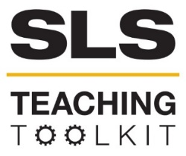 | Environmental Justice and the UN SDGs: A WAWA Case Study
Discipline: All | Type: In-class exercise, virtual exercise, take-home assignment, discussion | Time Commitment: 20-40 minutes | Category: UN Sustainable Development Goals; Green Infrastructure, Water, and Citizen Science
OVERVIEW:
The purpose of this tool is to introduce students to the work of the West Atlanta Watershed Alliance (WAWA) and the history of the Proctor Creek watershed, and to situate this work within the context of two United Nations Sustainable Development Goals: SDG 6, Clean Water and Sanitation, and SDG 10, Reduced Inequalities. Students will first explore the interactive WAWA StoryMap, which describes the history of environmental racism that led to the pollution of the Proctor Creek watershed and the work of WAWA and the local community in restoring the area. If more background is needed on the concepts of environmental justice and environmental racism, the use of this tool can be prefaced by using part or all of the SLS Environmental Justice 101 tool. After viewing the map, students will then read brief descriptions of two United Nations Sustainable Development Goals SDG 6 and SDG 10, and targets for each that are relevant to WAWA’s work. Use of this tool assumes students have some familiarity with the UN SDGs, but if this is not the case, this tool can be supplemented with information from SLS’s Resources for Teaching about the SDGs. Students will then engage in whole group or small group discussion (depending on instructor’s preference and time), exploring the linkages between the two SDGs, how WAWA’s work relates to targets in each on the local level, and how progress in the two SDGs relate to the environmental justice movement. Discussion questions can also be assigned as an individual take-home exercise.
This tool was contributed by Bonnie Lapwood.
INSTRUCTIONS:
- Provide a brief overview of the West Atlanta Watershed Alliance, then direct students to the WAWA StoryMap. Allow time for them to view each element in the map.
- Give a brief description of the UN SDGs, if needed, and invite students to consider the challenge in scaling global goals to local communities. Provide students with descriptions of SDGs 6 and 19, including the targets outlined below.
- In small groups or as a whole class, use the discussion questions as the basis for a conversation about the linkages between the two SDGs, how WAWA’s work relates to targets in each on the local level, and how progress toward the two SDGs relates to the environmental justice movement.
- Ask students to complete a Minute Paper as a reflection activity.

SLS STUDENT LEARNING OUTCOMES & ASSESSMENT:
The Serve-Learn-Sustain toolkit teaching tools are designed to help students achieve not only SLS student learning outcomes (SLOs), but the unique learning outcomes for your own courses. Reflection, concept maps, rubrics, and other assessment methods are shown to improve student learning. For resources on how to assess your students’ work, please review our Assessment Tools.
This tool is aligned with SLO 3. See the end of this tool for further details. More specifically, students completing this lesson should be able to:
- Explain the concept of environmental racism and its connection to watershed integrity in West Atlanta communities.
- Describe the role of community members in the history of the Proctor Creek watershed.
- Articulate how WAWA’s work can serve as a model for achieving SDG goals on a local level.
Want Help?
Rebecca Watts Hull is the contact for this tool. You can reach her at rwattshull@gatech.edu.

What is WAWA?
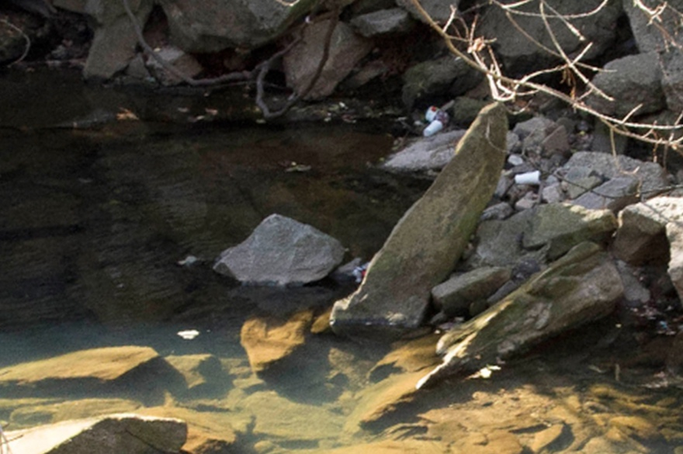
The West Atlanta Watershed Alliance (WAWA) originated from community action in the 1990s among multiple neighborhoods in West Atlanta’s watersheds. Community members organized to stop the city from building a combined sewer overflow (CSO) that would have threatened water quality and public health in the area. WAWA was officially founded in 1998 and serves as an advocacy organization for environmental justice and watershed health in Atlanta (WAWA StoryMap). WAWA has also been involved in the creation of parks and greenspace in the watershed area, and the organization officially oversees the Cascade Springs Nature Preserve and Lionel Hampton Beecher Park (US Water Alliance). WAWA aims to mobilize local residents and community members to get involved with their mission of environmental
Proctor Creek (WAWA)
stewardship (WAWA).
In 2020, WAWA published a StoryMap that traces the history of environmental racism through redlining, unjust sanitation and stormwater infrastructure, the founding of the organization and the recent emergence of threats of green gentrification with the building of the Atlanta BeltLine.

SDG 6: Clean Water and Sanitation and SDG 10: Reduced Inequalities
The United Nations Sustainable Development Goals (SDGS) are a set of 17 guiding principles for sustainable development as we approach the year 2030. Each of the 17 goals has an overarching theme and specific targets that relate to attaining the goal at the global level. However, the SDGs are meant to be applicable at multiple levels of governance, from the international level to individual cities and communities. The two SDGs highlighted below are particularly relevant to the work of WAWA. The following descriptions of these goals also include relevant targets for each SDG. Targets are meant to serve as guiding posts for different aspects of progress towards a goal, and each target is also associated with specific indicators to measure that progress.

The driving aim of SDG 6: Clean Water and Sanitation, is to “ensure availability and sustainable management of water and sanitation for all” (Global Goals). Targets include:
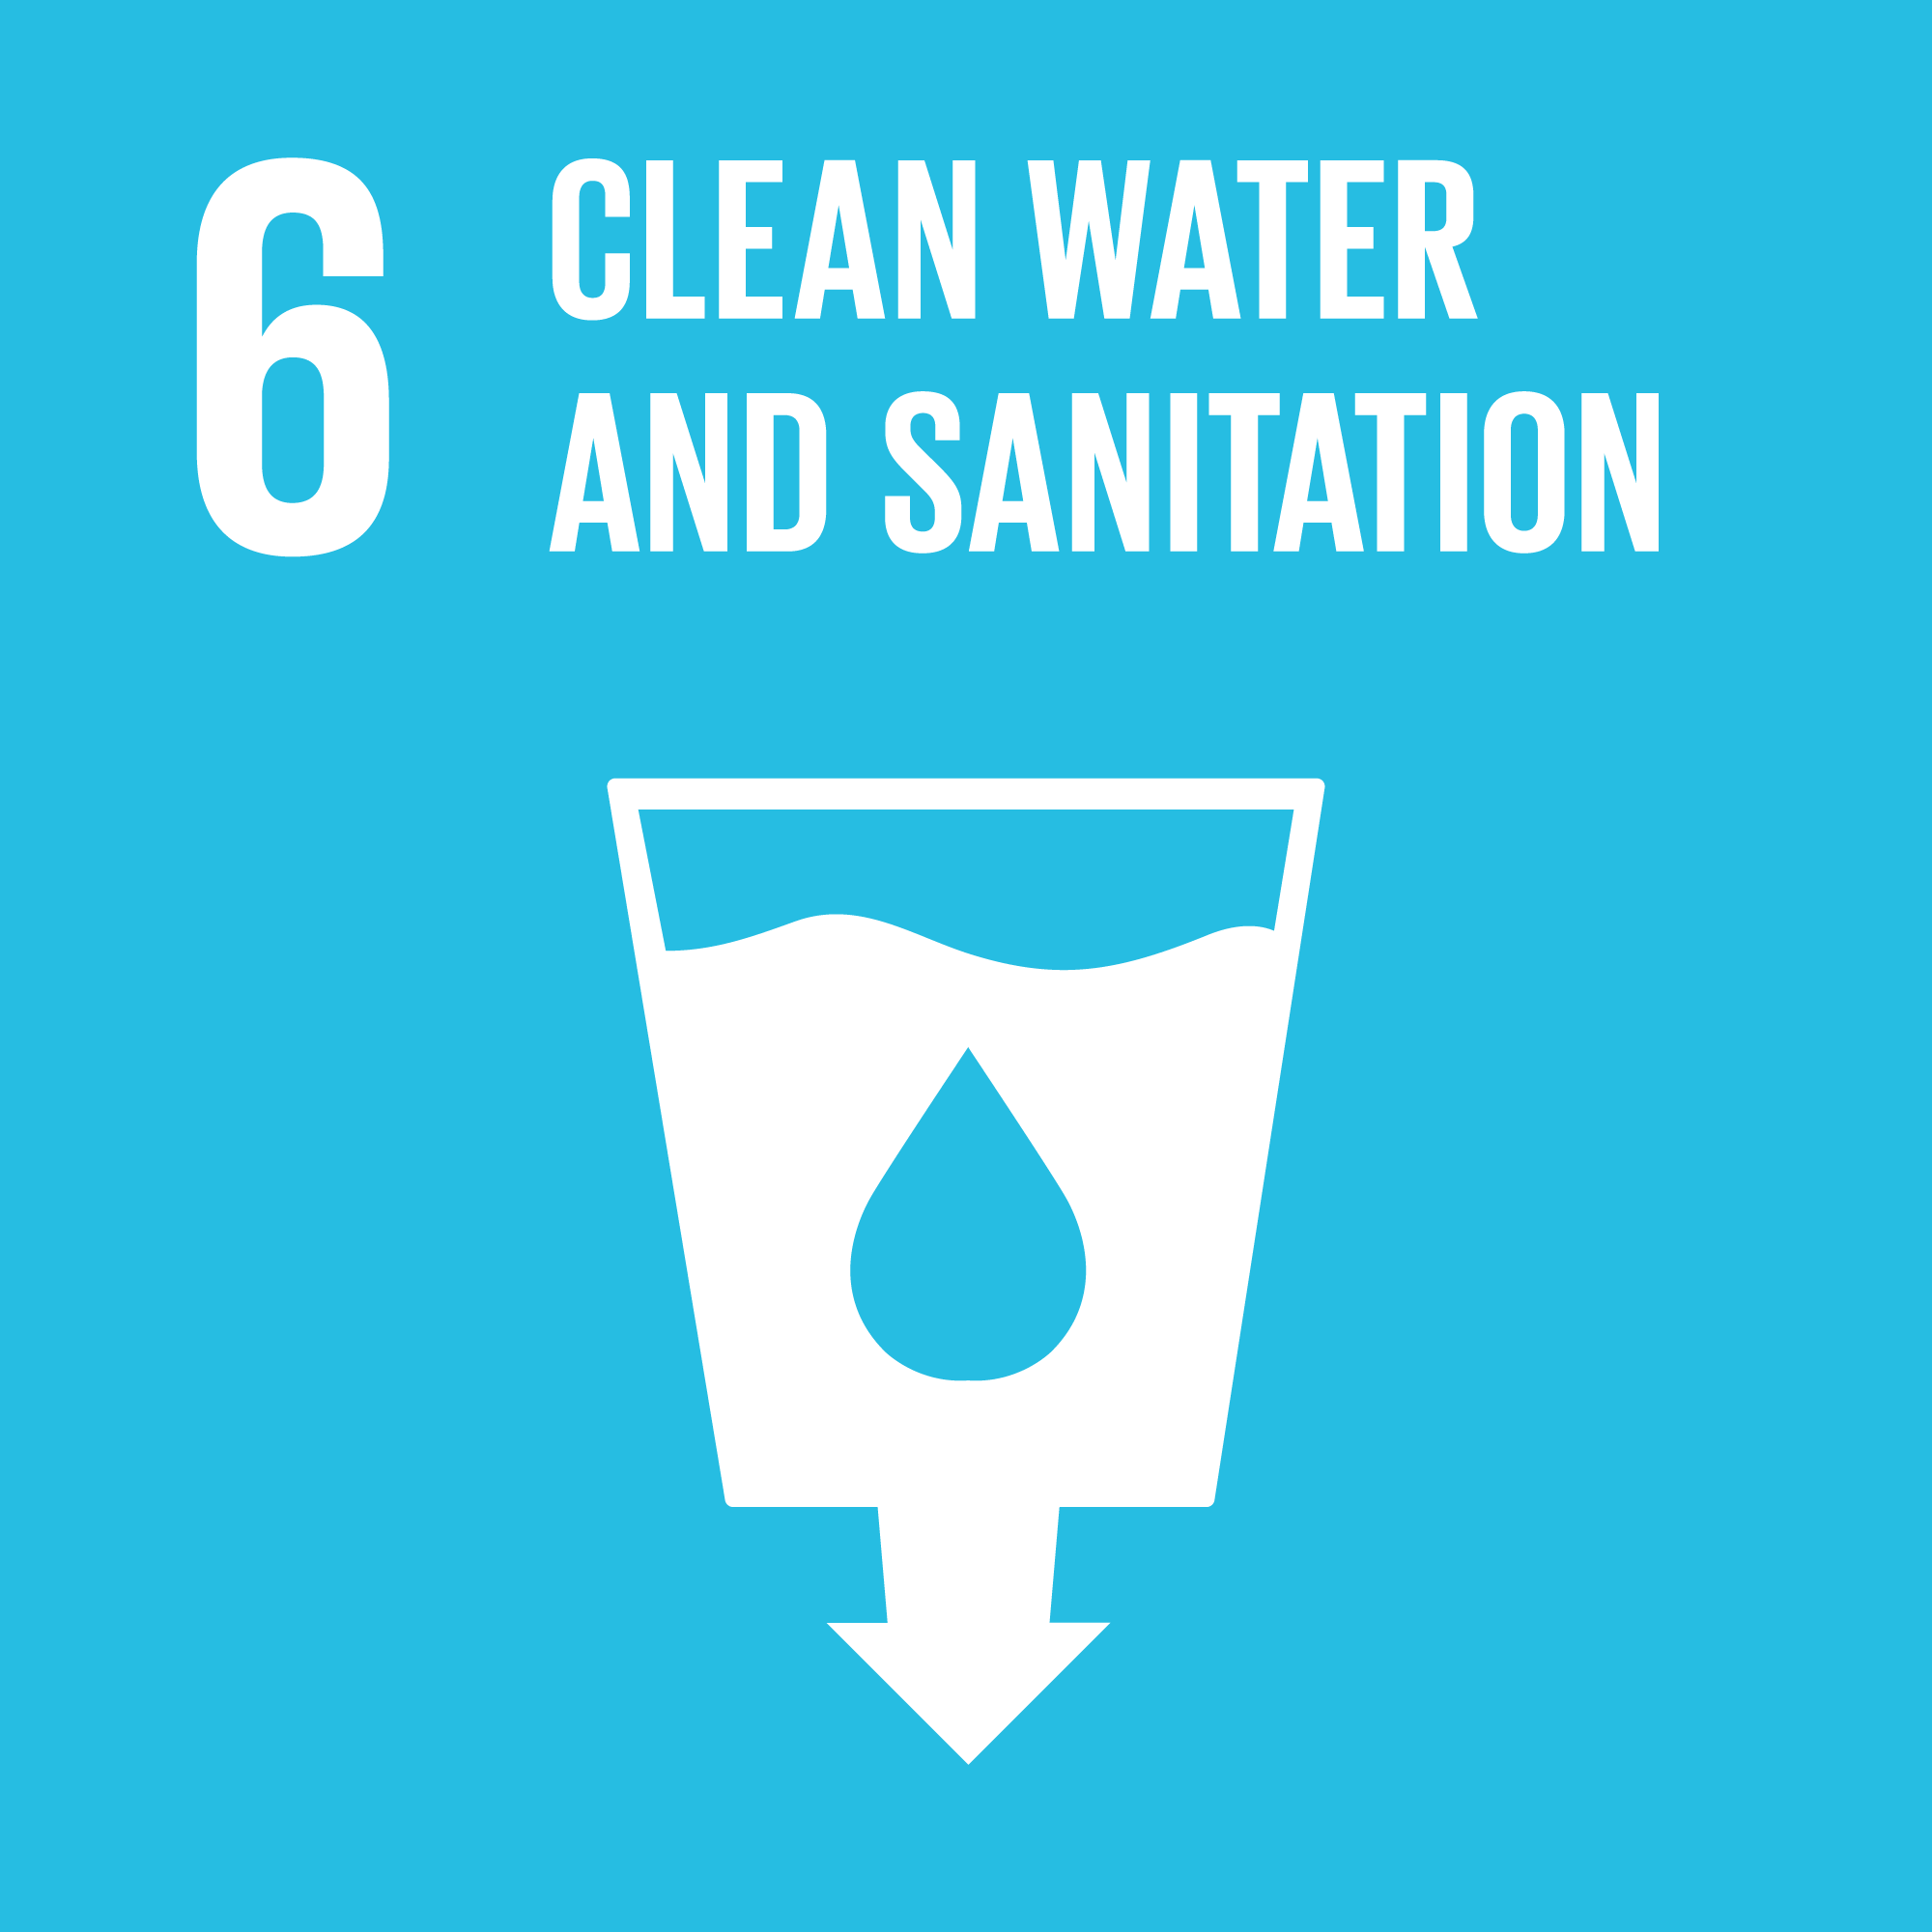
- Improve water quality, wastewater treatment and safe reuse
- Implement integrated water resources management
- Protect and restore water-related ecosystems
- Support local engagement in water and sanitation management
SDG 10, Reduced Inequalities, is concerned with “reducing inequality within and among countries.” Some key targets are:
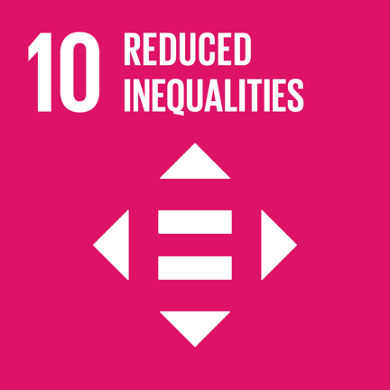
- Reduce income inequalities
- Promote universal social, economic and political inclusion
- Ensure equal opportunities and end discrimination
- Adopt fiscal and social policies that promote equality

Using this Tool
- If students need additional context for environmental justice and environmental racism, begin the activity with the SLS Environmental Justice 101 tool. If students need additional background on the UN SDGs, additional material can be found in SLS’s Resources for Teaching about the SDGs.
- Briefly introduce WAWA using the information above and provide students with access to the StoryMap. In an in-person setting this could be a link or it could be viewed collectively on the classroom screen. In a virtual setting, share your screen or provide students with the link and allow them to experience the StoryMap independently. Allow about 10-15 minutes for students to review the map contents.
- Introduce the two SDGs above, explaining that WAWA’s work can be considered within the context of sustainable development initiatives. Information on the two SDGs can be provided as a link to the respective pages on globalgoals.org or as a handout using the information provided above.
- Facilitate class or small group discussion using the discussion questions below. Questions can be amended or modified to fit class content.
- Have students reflect using the Minute Paper activity below.
- Use the optional extension below to go into detail about the multi-level nature of the SDGs.

Discussion Questions
- What is environmental racism?
- How is the impact of environmental racism visible in maps of Atlanta’s neighborhoods?
- What are the key challenges faced in Atlanta in terms of providing clean water and adequate sanitation for all residents?
- How do these challenges intersect with environmental racism?
- Who are the stakeholders in decision-making about clean water and sanitation in Atlanta? How have those stakeholders been included or left out of key decisions?
- What is WAWA’s role locally?
- How does WAWA’s work fulfill each of the targets described above for SDGs 6 and 10?
- How has the Atlanta BeltLine influenced inequalities on the westside of Atlanta?
- What is the relationship of the BeltLine and new greenspace investment to environmental justice and to environmental injustice?

Minute Paper

Set aside five minutes following the class or small group discussion. Ask students to respond to the question “What was the most important thing you learned during this lesson?” in writing and let them know how much time they will have. In a virtual setting, students could post in the chat, use a brainstorming application (such as Jamboard or Miro), or submit via Canvas. In an in-person setting, have students turn in what they have written (consider distributing index cards for this purpose). This exercise may be used to gauge students’ understanding of some of the lesson’s key concepts.

Optional Extension: Polycentric Governance
The purpose of connecting WAWA’s work with the UN SDGs is to illustrate the way that goals that are global in scope can be implemented and furthered on a local level, scaling all the way from the global to the community level. To further explore this connection, introduce students to the work of the US Water Alliance. The US Water Alliance is a non-profit advocacy and education organization that also brings together multiple water-related stakeholders as members. WAWA is a member, as is DeKalb County Department of Watershed Management. The purpose and benefits of linking action at different scales may be introduced through Elinor Ostrom’s concept of “polycentricity” – “governance and markets and multiple scales, interacting in complex ways.” Ask students to create a diagram of levels of governance for working towards SDG 6, including WAWA and the US Water Alliance along with other governmental entities and organizations related to their mission and vision.

Resources for Further Reading
Ashley, Jaclynn. “The Black residents fighting Atlanta to stay in their homes.” Al Jazeera, Nov. 30, 2020.
Global Goals for Sustainable Development, https://www.globalgoals.org
Immergluck, Dan, and Tharunya Balan. “Sustainable for whom? Green urban development, environmental gentrification, and the Atlanta Beltline.” Urban Geography (2017).
Jelks, Na’Taki Osborne O., Timothy L. L. Hawthorne, Dajun H. Dai, Christina H. Fuller, and Christine Stauber. "Mapping the Hidden Hazards: Community-led Spatial Data Collection of Street-level Environmental Stressors in a Degraded, Urban Watershed." International Journal of Environmental Research and Public Health 15, no. 4 (2018).
Ostrom, Elinor. “Beyond Markets and States: Polycentric Governance of Complex Economic Systems.” The American Economic Review 100, no. 3 (2010).
Stephan, Mark, Graham Marshall, and Michael McGinnis. “An Introduction to Polycentricity and Governance.” Governing Complexity, eds. Andreas Thiel, William Blomquist, and Dustin Garrick. https://mcginnis.pages.iu.edu/Stephan%20Marshall%20McGinnis%20Intro%20to%20Polyc%20Gov.pdf
US Water Alliance.
US Water Alliance, “West Atlanta Watershed Alliance.” http://uswateralliance.org/organization/west-atlanta-watershed-alliance
West Atlanta Watershed Alliance, http://wawa-online.org/.
West Atlanta Watershed Alliance Story Map, https://storymaps.arcgis.com/stories/51bf4b8341484de08154248f8c3ffa98

