 | London Olympic Park Stadium: Multi-Criteria Decision Matrix Exercise
Discipline: Engineering | Type: In-Class Exercise; Discussion; Reading | Time Commitment: 1 to 1.5 hrs | Category: Case Studies on Sustainable Communities
Big Ideas: Civic Design ; Design Thinking ; Systems Thinking
OVERVIEW:
In preparation for the 2012 Olympic Games in London, the Olympic Delivery Authority (ODA) faced an unprecedented design challenge: create an 80,000 capacity stadium with the flexibility to be converted to a 25,000 capacity venue after the Games, and do this while achieving the ODA’s sustainability objectives. In the case study below, you’ll discover how they achieved the brief through innovative design and engineering. Furthermore, you’ll use this tool to learn more about how you, too, can make difficult design choices without compromising sustainability. To that end, this tool introduces you to the Multi-Criteria Decision Matrix, or, Values-based Decision Making.
This tool was contributed by Kari Watkins.
INSTRUCTIONS:
- Assign your students the London Olympic Park Stadium Case Study, to be completed before the day of the in-class exercise.
- On the day of the exercise, take your students through this PowerPoint on Values-Based Decision Making.
- Either as individuals or in pairs, ask them to complete the activity instructions below. They will use this MCDM excel spreadsheet as a guide in developing a multi-criteria decision table for the Olympic Park Stadium design.
SLS STUDENT LEARNING OUTCOMES & ASSESSMENT:
The Serve-Learn-Sustain toolkit teaching tools are designed to help students achieve not only SLS student learning outcomes (SLOs), but the unique learning outcomes for your own courses. Reflection, concept maps, rubrics, and other assessment methods are shown to improve student learning. For resources on how to assess your students’ work, please review our Assessment Tools.
This tool achieves SLO 1 & 3 See the end of this tool for further details.
Want Help?
Kari Watkins is the contact for this tool. You can reach her at kari.watkins@ce.gatech.edu

London Olympic Park Stadium: Multi-Criteria Decision Matrix Exercise

Overview
In preparation for the 2012 Olympic Games in London, the Olympic Delivery Authority (ODA) faced an unprecedented design challenge: create an 80,000 capacity stadium with the flexibility to be converted to a 25,000 capacity venue after the Games, and do this while achieving the ODA’s sustainability objectives. In the case study below, you’ll discover how they achieved the brief through innovative design and engineering. Furthermore, you’ll use this tool to learn more about how you, too, can make difficult design choices without compromising sustainability. To that end, this tool introduces you to the Multi-Criteria Decision Matrix, or, Values-based Decision Making.
Before class, please review the London Olympic Park Stadium Case Study. While reading the case study, write down the relevant design criteria categories that the stadium planners likely considered during the design process.

Case Study Activity
Review this MCDM excel spreadsheet. Using it as a guide, develop a multi-criteria decision table for the Olympic Park Stadium design. Refer to the following figure as an example of design criteria categories and subcategories for a flooring system.
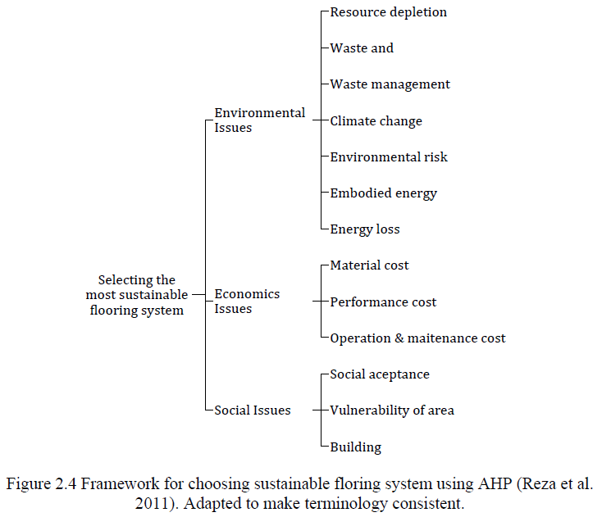
Figure 1: Analytical Hierarchy Process Framework for Choosing Sustainable Flooring System

Multi-Criteria Decision Table
C1. Safety  (Category) | C1.1 | Structural Fire Resistance (Subcategory)

SLS Student Learning Outcomes
- Identify relationships among ecological, social, and economic systems.
- Demonstrate skills needed to work effectively in different types of communities.
- Evaluate how decisions impact the sustainability of communities.
- Describe how to use their discipline to make communities more sustainable.*
* Note: SLO 4 is intended to be used by upper division, project-based courses such as Capstone.

